Put a static folder in the same folder with templates folder. In static folder, containing static files (e.g. images, JavaScript, CSS)¶
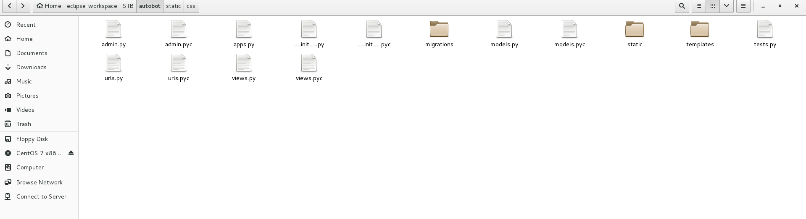

Step 1: In settings.py file
Add 'django.contrib.staticfiles' to INSTALLED_APPS
INSTALLED_APPS = [
'django.contrib.admin',
'django.contrib.auth',
'django.contrib.contenttypes',
'django.contrib.sessions',
'django.contrib.messages',
'django.contrib.staticfiles',
'autobot'
]

Step 2: In index.html file, include these lines
<!-- DEPLOYING STATIC FILES E.G. IMAGES, JAVASCRIPT, CSS -->
{% load static %}
<!-- DEPLOYING STATIC FILES E.G. IMAGES, JAVASCRIPT, CSS -->
<link href="{% static 'css/font-awesome/css/font-awesome.min.css' %}" rel="stylesheet" type="text/css" />

